Yanks at a Roundabout

Imagine you are driving in England and you are already confused enough driving on the left side. Then you see this sign:
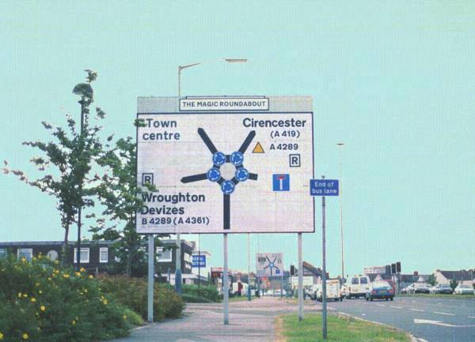
and you ask yourself – what’s gonna happen here ?
all of a sudden there it is ...

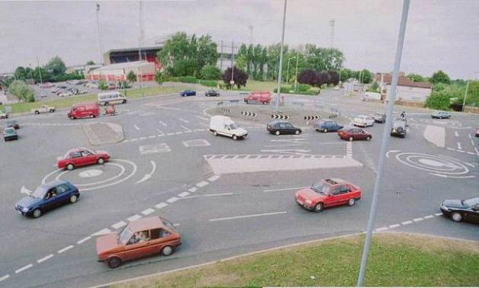

The magic roundabout!
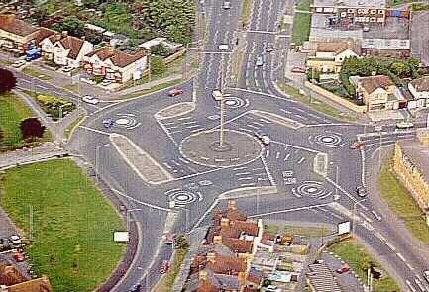

Supposedly there are 3 or 4 of these in England.
In Swindon, in London and Cardiff (England???).

In the middle the direction is reversed.

Those Brits are crazy. No wonder that god put them on an island.
YEEHAW!!

